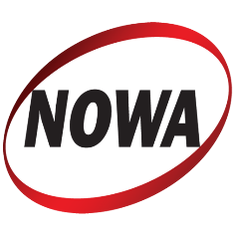 | Membership Application

Applicant Name:

Address:

Telephone: |  | Cellphone:

Email:

Website:

Professional Bio: (25-50 words preferred)

NOWA Membership is by invitation. Members may belong to one or both of our interest groups. Regardless of which group they are joining, the board must review all new applicants. Please check the group(s) you are interested in joining.

Author Interest Group
Professional Communicator Interest Group

 | Copywriter |  | Photographer |  | Illustrator |  | Graphic Designer |  | Video

(Communicators must provide two letters of recommendation and a portfolio of their work.)

Dues for 2025 are $25, payable at the beginning of the year.

Email this application to bale@balefirecom.com | Mail your dues check for $25 to:  NOWA  330 East Hendricks Blvd.  South Plainfield, NJ 07080

Authors must have published at least one quality book. Authors may need to submit a book copy for membership approval.
Professional Communicators are those who hire out their services and must follow the NOWA Code of Ethics. All communicator applicants must provide two letters of recommendation and undergo a portfolio review.

